[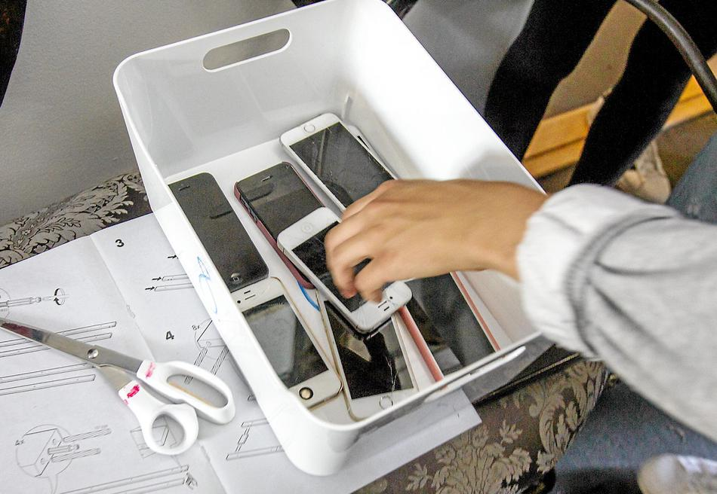](https://www.google.dk/url?sa=i&rct=j&q=&esrc=s&source=images&cd=&cad=rja&uact=8&ved=2ahUKEwj3vruWtvndAhUSaFAKHS46C5wQjRx6BAgBEAU&url=https%3A%2F%2Fsn.dk%2FFredensborg%2FSkole-forbyder-mobiltelefoner-Boernene-skal-lege%2Fartikel%2F511531&psig=AOvVaw1pIllj0msw-w2ZkZFn--wL&ust=1539176606776648)